Why Time Management?

‘Time isn’t the main thing. It’s the only thing.’
—Miles Davis

Time is the most valuable resource to help us achieve our goals and fulfil our aspirations. Unlike other resources, like wealth, power and intelligence, we all have the same duration of time at our disposal. However, time is also perishable because once gone, it never comes back. Steve Jobs rightly said, ‘It’s really clear that the most precious resource we all have is time.’ Therefore, if we waste our time, we waste our life.
Many people have a claim on our time. We have numerous responsibilities for our family, friends, colleagues and society, and we need time to fulfil all these obligations. We also need time to understand and solve our personal and professional problems.
We are often busy firefighting urgent problems that demand our immediate attention. Yet, even before we solve one problem, another arrives. As a result, we have no time to plan what we aspire to do in our lives. Sometimes, we also lack the knowledge and skill to make the best use of our time. When we are not at peace with ourselves or have pending work, we can’t focus on the task at hand. As a result, our productivity is low, and it takes more time to complete the job.
If we cannot manage our time well, we fail to fulfil our commitments. As a result, we miss deadlines and appointments. We often face financial penalties because we either cannot complete a task on time or deliver an inferior quality of the work. As a result, we may lose our professional and personal reputation because people won’t trust us to deliver what we promise.
When we fail to manage time well, our relationships with our bosses, subordinates, clients, family members and friends get strained. As a result, our work quality goes down, and we develop the tendency of procrastination. We have a low work-life balance when we have no time for our family, which often leads to a bad relationship with our spouse, children and parents. When we cannot perform our jobs well, our careers suffer. As a result, we have no time to realise our cherished dreams, aspirations and passions or realise our full potential and fulfil our life’s mission.
Time Management
Time management is the process of planning and exercising conscious control of the time spent on specific activities to maximise effectiveness, efficiency and productivity. We can balance our various demands relating to work, social life, family, hobbies, personal interests and other commitments with good time management practices.
We know that we need food that provides us with nutrients like proteins, carbohydrates and vitamins for good health. If even one of the nutrients is missing, we feel unwell. Similarly, good time management helps us create more time to fulfil all our needs and lead a balanced life.
Time management also generates time to create a better future. We have time to think about our future and visualise where we wish to be in one year, five years or after a few decades. Accordingly, we can build the necessary capacity by learning new skills and upgrading our knowledge. With time at hand, we can follow our passion and hobbies. We can also have faster career growth and even more wealth creation because we improve our efficiency and effectiveness with time management. As a result, we meet our deadlines and perform our jobs well. Most importantly, we create additional time for self-actualisation and realise our full potential.
Greek philosopher Aristotle said, ‘Anybody can become angry— that is easy—but to be angry with the right person, and to the right degree, and at the right time, and for the right purpose, and in the right way, that is not within everybody’s power and is not easy.’
We can rephrase the quote as: ‘Anybody can spend time—that is easy—but to spend time with the right person, and to the right degree, and at the right time, and for the right purpose, and in the right way, that is not within everybody’s power and is not easy.’
Good time management aims to fulfil all our needs to help us lead a happy and fulfilled life.
Human Needs
In 1943, American psychologist Abraham Maslow introduced the concept of a five-tiered ‘Hierarchy of Needs’ , which can be represented in the form of a pyramid (Figure 1).
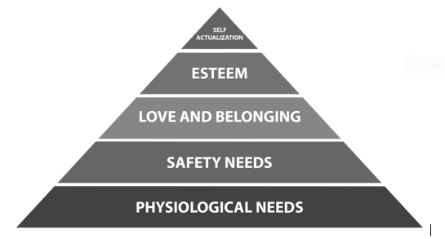
Figure 1: Maslow’s Hierarchy of Needs
At the bottom of the pyramid, we find our physiological needs that are necessary for survival. Such requirements include air, water, food, shelter, sleep, clothing, reproduction and sex. The next in the hierarchy is our safety needs, which means our personal security, gainful employment, sufficient financial reserves, health and property. If we have acquired sufficient property, a good bank balance or a job with an assured regular income, we feel secure and safe since we are confident that we can also take care of our physiological needs in the future. Next comes the need for love and belonging, which includes the desire to have friendship, intimacy, family and a sense of connection. These are our emotional needs whose fulfilment is necessary for happiness.
Once our lower-level needs are satisfied, we move towards the higher need of ‘Esteem’, where we want respect, self-esteem, status, recognition, strength and freedom. These needs satisfy our ego. If we have all these needs (fulfilled), we feel valued and joyful. Finally, the topmost human need in the pyramid is ‘Self-actualisation’, or the desire to realise our full potential.
In order to live a good life, we must fulfil all our needs. But, unfortunately, we are so busy fulfilling our day-to-day commitments that we find no time to satisfy all our needs and realise our full potential. Time is the resource that is essential to achieve anything in life. Hence, if we can manage our time well, we can fulfill all our needs and lead a happy and satisfied life.

